____________________________________________

Celebrating Edward Vernal Ellis
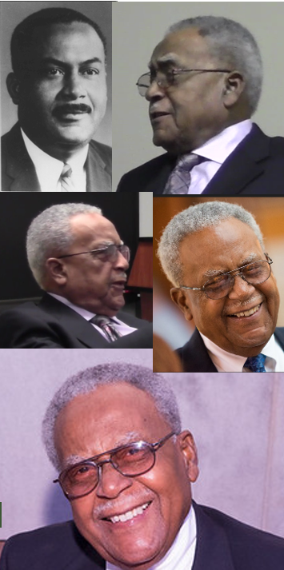
* B.S., Shaw University, Raleigh, NC, 1949.
* M.S.P.H., North Carolina Central University, 1950
* Ph.D., UNC School of Public Health, Aug. 1964 (three months after UNC awarded its first PhD to an African American).
* Vice President of Academic Affairs, University of Maryland Eastern Shore, 1983-1994 (and then Professor Emeritus)
. . . (see over)

https://go.unc.edu/EdwardEllis
____________________________________________

____________________________________________

Celebrating Edward Vernal Ellis
* B.S., Shaw University, Raleigh, NC, 1949.
* M.S.P.H., North Carolina Central University, 1950
* Ph.D., UNC School of Public Health, Aug. 1964 (three months after UNC awarded its first PhD to an African American).
* Vice President of Academic Affairs, University of Maryland Eastern Shore, 1983-1994 (and then Professor Emeritus)
. . . (see over)

https://go.unc.edu/EdwardEllis
____________________________________________

____________________________________________

Celebrating Edward Vernal Ellis
* B.S., Shaw University, Raleigh, NC, 1949.
* M.S.P.H., North Carolina Central University, 1950
* Ph.D., UNC School of Public Health, Aug. 1964 (three months after UNC awarded its first PhD to an African American).
* Vice President of Academic Affairs, University of Maryland Eastern Shore, 1983-1994 (and then Professor Emeritus)
. . . (see over)

https://go.unc.edu/EdwardEllis
____________________________________________

____________________________________________

Celebrating Edward Vernal Ellis
* B.S., Shaw University, Raleigh, NC, 1949.
* M.S.P.H., North Carolina Central University, 1950
* Ph.D., UNC School of Public Health, Aug. 1964 (three months after UNC awarded its first PhD to an African American).
* Vice President of Academic Affairs, University of Maryland Eastern Shore, 1983-1994 (and then Professor Emeritus)
. . . (see over)

https://go.unc.edu/EdwardEllis
____________________________________________
____________________________________________
(continued from reverse)
* Associate Dean for Continuing Education / Commonwealth Campuses and Associate Professor of Public Health, College of Human Development, Pennsylvania State University, University Park, 1969-1982
* Assistant Professor, Graduate Program in Health Education, School of Public Health, University of Minnesota, Minneapolis, 1967-1969
* Director, Division of Public Health Education, Pennsylvania Department of Health (Penn DOH), Harrisburg, PA, 1964-1966
* Chief, Communicable Disease Section, Division of Public Health Education, Penn DOH, Harrisburg, 1963-1964
* Health Education Consultant, Division of Chronic Diseases, Penn DOH, Harrisburg, 1955-1963
* Associate Health Educator, District of Columbia Tuberculosis Association, 1952-1955
* Instructor, North Carolina Central University, 1951-1952

Videos at https://go.unc.edu/EdwardEllis

Vic Schoenbach, go.unc.edu/vjs
____________________________________________

____________________________________________
(continued from reverse)
* Associate Dean for Continuing Education / Commonwealth Campuses and Associate Professor of Public Health, College of Human Development, Pennsylvania State University, University Park, 1969-1982
* Assistant Professor, Graduate Program in Health Education, School of Public Health, University of Minnesota, Minneapolis, 1967-1969
* Director, Division of Public Health Education, Pennsylvania Department of Health (Penn DOH), Harrisburg, PA, 1964-1966
* Chief, Communicable Disease Section, Division of Public Health Education, Penn DOH, Harrisburg, 1963-1964
* Health Education Consultant, Division of Chronic Diseases, Penn DOH, Harrisburg, 1955-1963
* Associate Health Educator, District of Columbia Tuberculosis Association, 1952-1955
* Instructor, North Carolina Central University, 1951-1952

Videos at https://go.unc.edu/EdwardEllis

Vic Schoenbach, go.unc.edu/vjs
___________________________________________
____________________________________________
(continued from reverse)
* Associate Dean for Continuing Education / Commonwealth Campuses and Associate Professor of Public Health, College of Human Development, Pennsylvania State University, University Park, 1969-1982
* Assistant Professor, Graduate Program in Health Education, School of Public Health, University of Minnesota, Minneapolis, 1967-1969
* Director, Division of Public Health Education, Pennsylvania Department of Health (Penn DOH), Harrisburg, PA, 1964-1966
* Chief, Communicable Disease Section, Division of Public Health Education, Penn DOH, Harrisburg, 1963-1964
* Health Education Consultant, Division of Chronic Diseases, Penn DOH, Harrisburg, 1955-1963
* Associate Health Educator, District of Columbia Tuberculosis Association, 1952-1955
* Instructor, North Carolina Central University, 1951-1952

Videos at https://go.unc.edu/EdwardEllis

Vic Schoenbach, go.unc.edu/vjs
____________________________________________

____________________________________________
(continued from reverse)
* Associate Dean for Continuing Education / Commonwealth Campuses and Associate Professor of Public Health, College of Human Development, Pennsylvania State University, University Park, 1969-1982
* Assistant Professor, Graduate Program in Health Education, School of Public Health, University of Minnesota, Minneapolis, 1967-1969
* Director, Division of Public Health Education, Pennsylvania Department of Health (Penn DOH), Harrisburg, PA, 1964-1966
* Chief, Communicable Disease Section, Division of Public Health Education, Penn DOH, Harrisburg, 1963-1964
* Health Education Consultant, Division of Chronic Diseases, Penn DOH, Harrisburg, 1955-1963
* Associate Health Educator, District of Columbia Tuberculosis Association, 1952-1955
* Instructor, North Carolina Central University, 1951-1952

Videos at https://go.unc.edu/EdwardEllis

Vic Schoenbach, go.unc.edu/vjs
____________________________________________

