Syllabus for GUTS Lecture on Protein Structure and Function
I. Learning Objectives:
After completing this lecture you should be able to :
- describe the formation of a peptide bond including the functional groups involved, the products of the reaction, and the direction of growth of a polypeptide chain.
- describe the difference between a peptide and a protein.
- describe what is meant by the term primary, secondary, tertiary and quaternary structure of a protein and know the types of bonds and interactions that stabilize each of these structures
- define the terms cofactor, prosthetic group, and denaturation as they pertain to protein structure
- describe how heat, strong acids and bases, heavy metals, chaotropic agents and organic solvents denature proteins
- describe what proteases do

II. Amino Acids to Proteins.
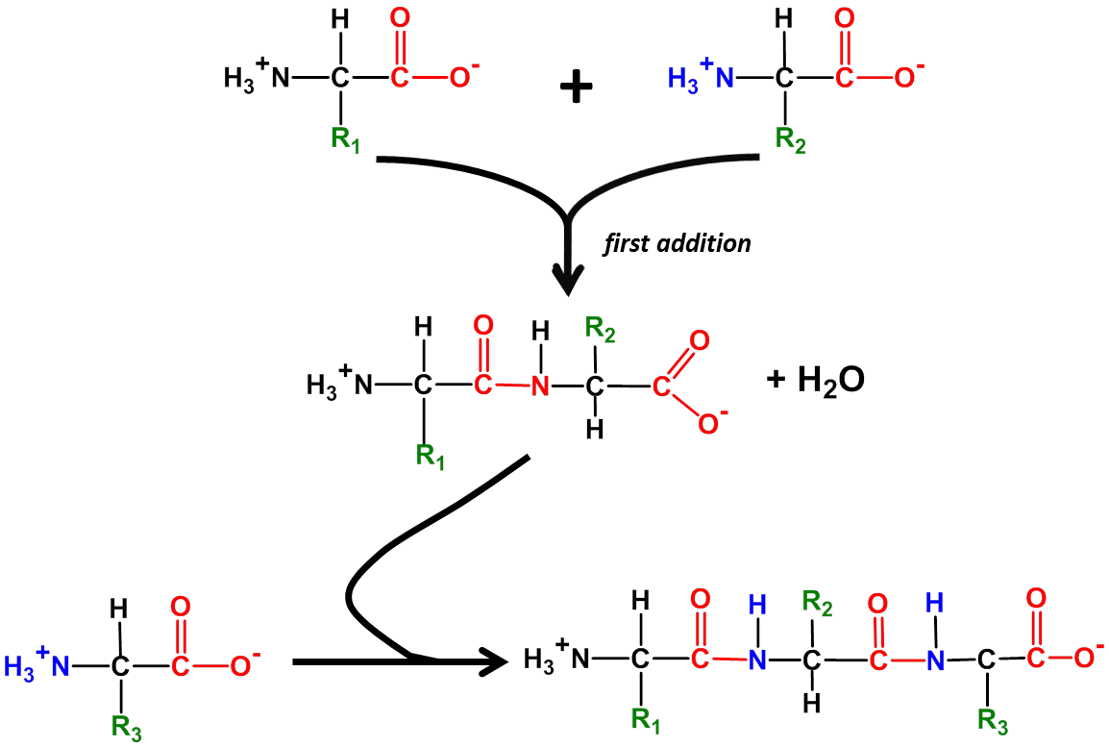
The amino acids found in proteins are linked together by peptide bonds, formed in a dehydration reaction (water is removed) between the α-carboxylate group on one amino acid and the α-amino group on another amino acid. In cells the amino acid chain always grows from left to right as drawn in the figure. Since this always leaves a nonbonded amino group on the left end and a nonbonded carboxylate group on the right end, these ends are called respectively the amino-terminal end and the carboxy-terminal end. The direction of chain growth is thus from the amino-terminal end toward the carboxy-terminal end. The sequence (order) of amino acids is dictated by the genetic code in DNA.
Peptide bond

Due to its proximity to a carbon with a double bond, the peptide bond has partial double bond character – specifically it is shorter than a single bond and is rigid and planar. This prevents rotation around the peptide bond. The rest of the bonds in the backbone of the chain, as well as the bond linking the R groups to the backbone, can rotate freely (with one exception), allowing the chain to assume a variety of conformations (shapes) in space. Often the positions of the R groups alternate above and below the plane of the backbone as this reduces steric or charge-repulsion interference between R groups.

III. Peptides, polypeptides and proteins.
Each of these consists of amino acids linked together by peptide bonds to form linear chains. The difference between these is the length of the amino acid chain. Depending upon the reference you consult, you will find peptides described as having fewer than a dozen or so amino acids; polypeptides are often described as containing as many as 70 amino acids. Polypeptides larger than this are generally called proteins. Proteins can have many hundreds or even thousands of amino acids linked together in a single linear chain. The largest know protein is Titan, which in humans contains 34,350 amino acids.

In addition to the linear chain of amino acids in a protein, additional components may be part of a complete, functional protein. The most common additional components are a single ion or a prosthetic group called a cofactor. Cofactors are not proteins and are required for a protein to carry out its function.
IV. Levels of Protein Structure.
As they are being synthesized, proteins begin to fold into more complex shapes, determined by the sequence of amino acids within each protein. The amino acid sequence of a protein is called its primary structure.

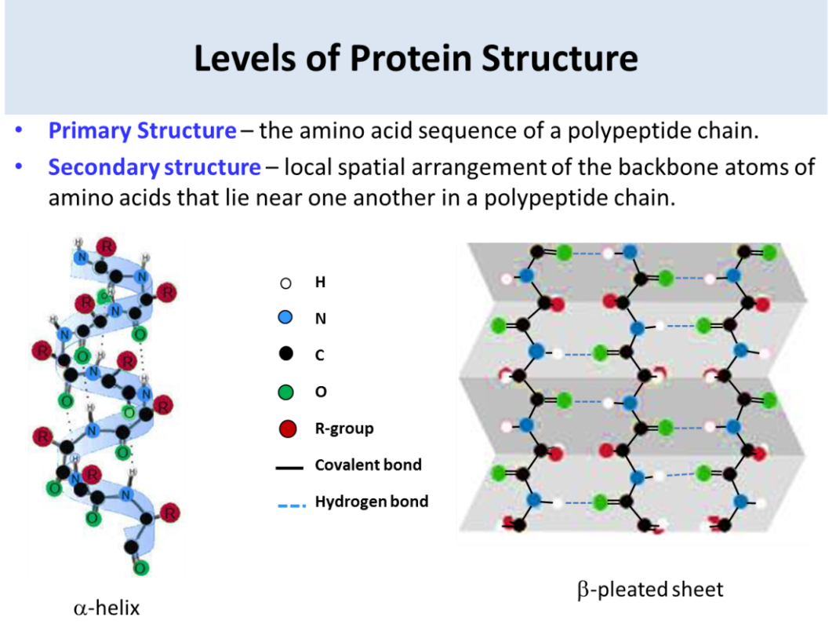
As a protein folds, regions of the backbone assume defined secondary structures such as the alpha-helix or the beta-pleated sheet. Secondary structures form because the structures maximize hydrogen bonding of all peptide-bond carbonyl-oxygens and amide- hydrogens in the protein backbone. The alpha-helix is a spiral structure consisting of a single, tightly-coiled polypeptide backbone with the R-groups (side chains) extending outward from the backbone. With the exception of the amino acid at each end of the helix, all nitrogens and oxygens in the alpha-helix backbone are involved in hydrogen bonds with an amino acid three residues further along the chain. The position of the R-groups on the outside of the helix allows them to interact with other molecules or with other parts of a polypeptide chain. Most amino acids can be incorporated into a smooth, regular alpha-helix structure; the exception is proline which has a kinked backbone that causes the helix to bend. (Recall that the backbone of proline is bent compared to all other amino acids.)

In contrast to the tight-coil of the alpha-helix, the backbone of the beta-pleated sheet is almost fully extended. Hydrogen bonds between backbone groups involve either a single polypeptide chain that folds back on itself or that forms from two separate regions of polypeptide chain. All backbone carbonyl oxygens and amide-nitrogens are involved in hydrogen bonding except for those on the edge of the sheet.

While the alpha-helix and beta-pleated sheet are folding, the backbone surrounding these structures is also folding to form more complex regional structures, called domains. In addition, there are regions of nonrepetitive secondary structures, called loops or coils, that link helices or sheets. Loops and coils do not have a random structure, but simply have less regular, repeating secondary structure that alpha-helices or beta sheets.
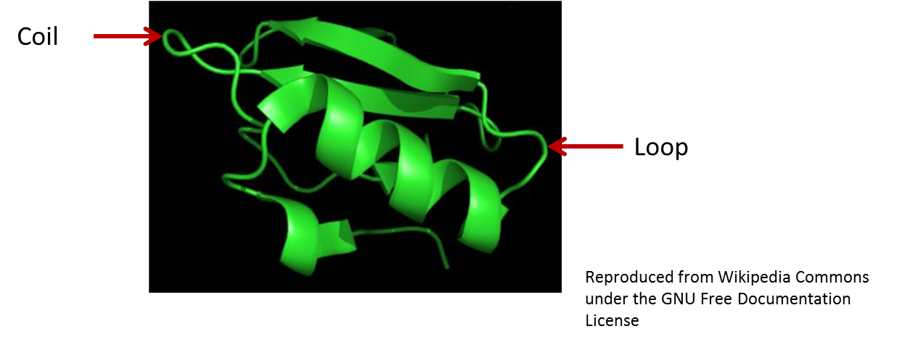
β-pleated sheet
α-helix
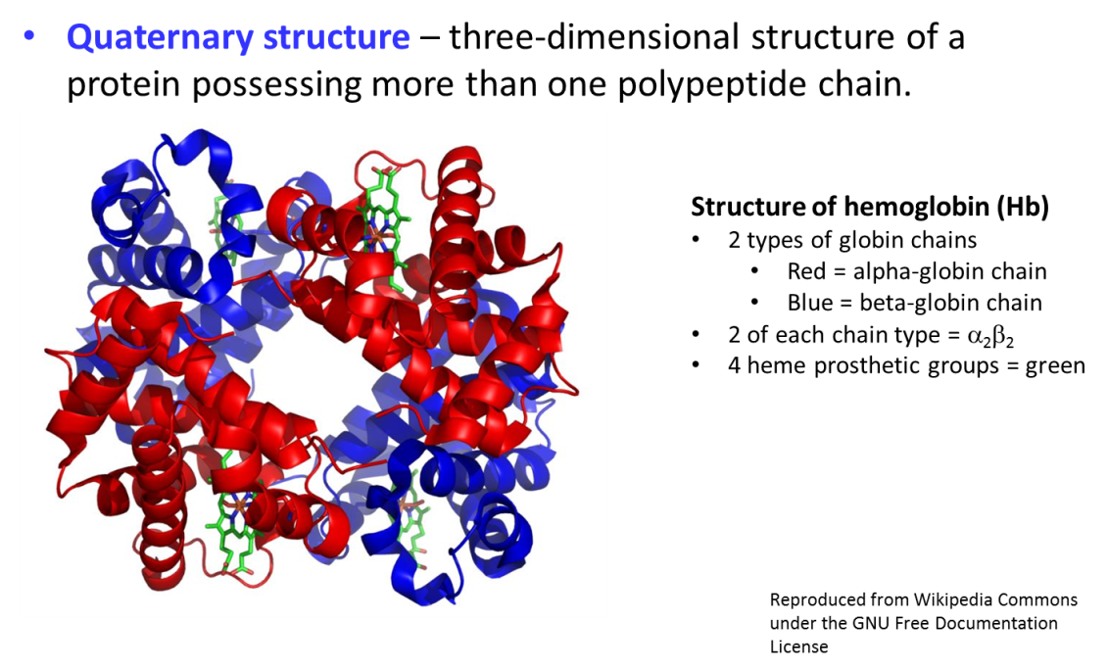
The figure above is of a portion of a 70-amino acid long protein called Chymotrypsin Inhibitor 2. As with most proteins, this one is composed of a mixture of α-helix and beta-pleated sheet. The overall fold and 3-dimensional structure of this molecule is an example of another level of protein structure called the Tertiary Structure. Another term for the overall 3D structure of a protein is conformation.
Many proteins contain multiple subunits. The number, type and spatial relationship of these subunits to one another in the 3-dimensional structure of the protein is called the quaternary structure. The figure shows the structure of a molecule of hemoglobin. It is composed of 4 globin chains; 2 of these are of the α globin type and two are of the β globin type. One of the advantages of multi-subunit proteins is that a change in shape of one subunit can be transmitted to other subunits and alter the behavior of these subunits. In the case of hemoglobin, when O₂ binds at one heme group it causes a conformational (shape) change in that subunit; this change causes other subunits to change shape and changes the affinity of their heme groups for O₂.

V. Cofactors, coenzymes and prosthetic groups.
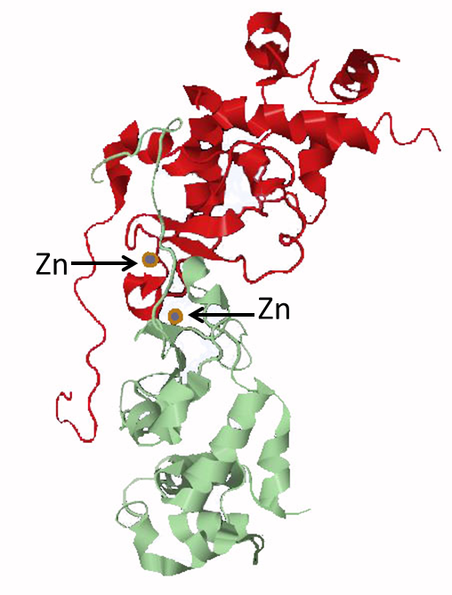
In addition to the amino acid chain, some proteins require additional cofactors to carry out their functions. (Cofactors are small molecules bound to the protein but that not synthesized as part of the amino acid chain.)

The structure on the right is that of the regulatory subunit of casein kinase II. The structure is a dimer of two identical molecules, each carrying an atom of its cofactor, zinc. In this case zinc forms bonds to 4 different histidine side chains found in the nearby coil and short helical region. Zinc binding stabilizes the folding of the protein in this region; removal of zinc causes this region to assume a different, nonfunctional, conformation (shape).
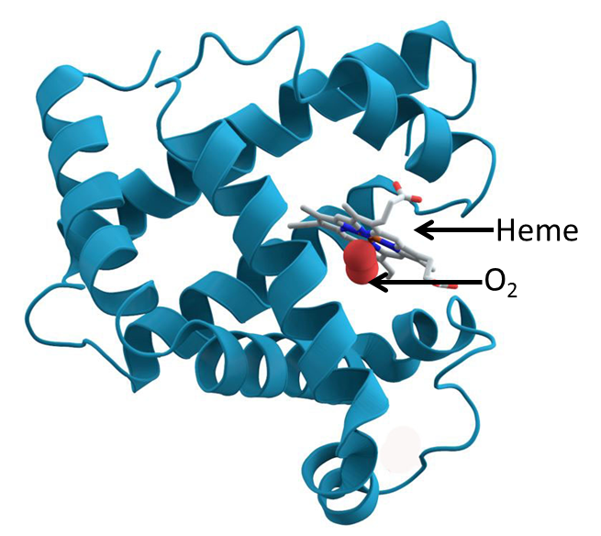

The structure shown on the left is that of myoglobin, the protein that binds oxygen within muscle cells. The protein is composed entirely of alpha-helices linked together by loops or coils. In addition, myoglobin carries a prosthetic group known as heme. A prosthetic group is a nonprotein cofactor that is tightly bound to a protein; it does not dissociate from the protein under normal physiological conditions. Most of the heme group consists of a porphyrin ring (in grey). At the center of the heme group a single atom of iron is bound to the porphyrin ring. It is the iron in heme that binds directly to molecular oxygen (O₂) in myoglobin. The rest of the prosthetic group is necessary to make O₂ binding by iron reversible under physiological conditions. Without heme, myoglobin cannot carry out its function. Hemoglobin, a molecule discussed above, has one heme bound by each of its 4 protein chains and thus can carry 4 times as much oxygen as myoglobin.

VI. Protein Denaturation and Degradation.
The complex folded structures of proteins are held together by weak bonds – hydrogen bonds, ionic interactions, hydrophobic interactions and disulfide bonds. These bonds are easily broken by a number of chemical and physical agents. Loss of protein tertiary or secondary structure is termed denaturation.
- Many human proteins denature at temperatures above about 45^{O} C, which is one reason that humans cannot withstand high fever or exposure to high temperature for a long time.
- Strong acids and bases change the pH of the solution containing proteins and therefore change the ionization of acidic and basic side chains, leading to disruption of ionic bonds.
- Heavy metals, because they are charged, also bind to charged side chains, disrupting salt bridges (ionic bonds).
- Organic solvents are often nonpolar and therefore the charged and ionic groups on the protein’s surface will tend to move toward the interior of a protein (and hydrophobic side chains move outward toward the solvent); essentially the protein adopts a new structure with the polar group toward the inside and hydrophobic groups on the outside.

In addition to denaturation, proteins also undergo degradation. Inside of cells this is part of the normal life cycle of proteins, which have half-lives from minutes to over 100 years depending upon the specific protein. Protein degradation is carried out by enzymes called proteases. These enzymes cleave peptide bonds linking together amino acids in a protein chain. Different proteases have different specificities, some degrading from the carboxy-terminus and others cleaving bonds between specific amino acids or types of amino acids within the protein chain. Proteases also play major roles in immunity and in cancer metastasis.

Proteins can also be degraded outside of cells by chemical and physical factors. A combination of strong acid and heating at 110º C overnight is needed to degrade a protein to single amino acids.

