Syllabus for GUTS Lecture on DNA and Nucleotides

I. Introduction. DNA is the instruction manual for how to build a living organism here on earth. The instructions in DNA are propagated to future generations of cells through DNA replication and are expressed during transcription and translation of the genetic code carried in DNA. This GUTS lecture covers the fundamental properties of DNA that you need to know to understand replication, transcription, mutagenesis and DNA repair. It is probable that you have been previously introduced to these concepts during your undergraduate training or during your preparation for the MCAT and that this lecture simply serves as a refresher.

II. The building blocks of DNA are deoxyribonucleotides. Four deoxyribonucleotides are commonly found in DNA. Each consists of a molecule of the sugar deoxyribose linked to a phosphate group at the C5’ position of the sugar; in addition the sugar is linked via a covalent bond (called a glycosidic bond) at C1’ to a nitrogenous base. Note also the –OH group at C3’ of deoxyribose; this group and the C5’ phosphate are involved in linking together nucleotides in DNA chains. Four nitrogenous bases commonly occur in DNA: adenine (A), guanine (G), thymine (T) and cytosine (C). A and G are purine bases and T and C are pyrimidine bases. Each of these bases, with the exception of thymine, are found on both DNA and its cousin RNA. Thymine is found only in DNA, not in RNA.

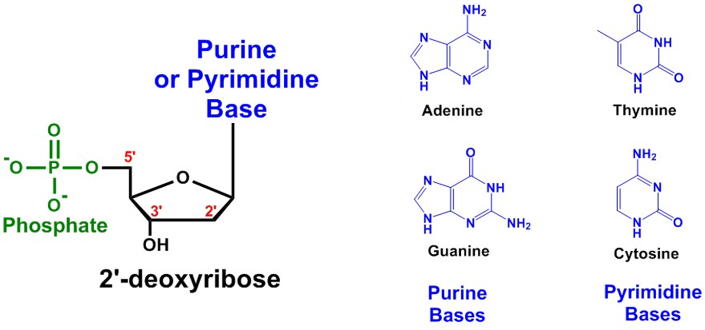

III. Important Structural Features of DNA. In DNA two strands of deoxyribonucleotides wrap around a common axis in a characteristic structure called the double helix. In each strand deoxyribonucleotides are linked together via phosphodiester bonds between the C5’ carbon on one deoxyribose and the C3’ carbon on the adjacent nucleotide in the same strand. This bonding pattern gives DNA a directional asymmetry, called polarity. As one moves along the double helix, the two strands of DNA are antiparallel; in one strand the polarity is 5’ 3’ moving from bottom to top of the helix, and in the other strand the polarity runs 3’ 5’ from bottom to top. The polarity of a DNA strand is a key feature that is recognized by many enzymes that act on DNA.

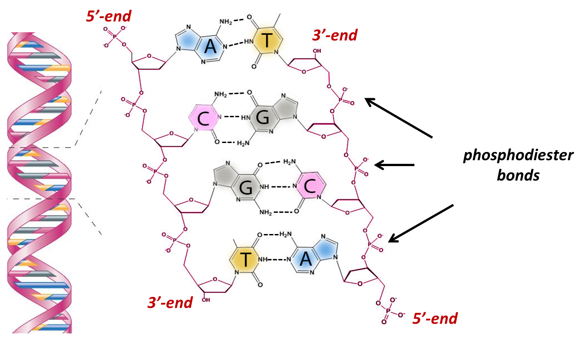

The nitrogenous bases of DNA lie in the center of the helix with their planar rings perpendicular to the central axis of the helix. Adenine bases (A) pair with Thymine bases (T) via two H-bonds, and Guanine (G) pairs with Cytosine (C) via 3 H-bonds. This base pairing pattern as complementary base pairing and the bases that pair with one another are often called complements. Complimentary base pairing maximizes hydrogen bonding between the bases and maintains a constant helix diameter by placing a bulky purine across the helix from a less-bulky pyrimidine. Other H-bond pairings between bases are seen rarely but can be important in mutagenesis and DNA repair processes. Hydrogen bonding between bases is one of the main forces stabilizing the double-helical structure.

Complimentary base pairing is one of the most important features of DNA because it provides a mechanism for the faithful duplication of the genetic material. Either strand of the DNA can serve as a template for the assembly of the complementary strand. To describe this property, we say that the information in DNA is redundant. The same rules for base pairing are also used in the expression of genetic information during transcription and translation and in many types of DNA repair processes.

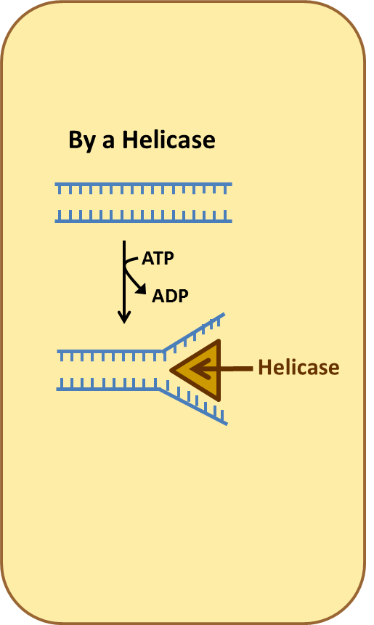
IV. Unwinding DNA. For processes such as replication and transcription, the helix undergoes transient, partial unwinding to allow enzymes such as DNA polymerase and RNA polymerase to “read” the base sequence. In many cases unwinding requires enzymes known as helicases; these enzymes use energy derived from ATP hydrolysis to unwind portions of the helix. Helicases recognize the polarity of DNA stands; when presented with the ends of DNA strands, they recognize the structure at the end of the strand and move either 5’ to 3’ or 3’ to 5’ depending upon the particular helicase. Mutations in helicases are causative for several genetic disorders with significant pathology.

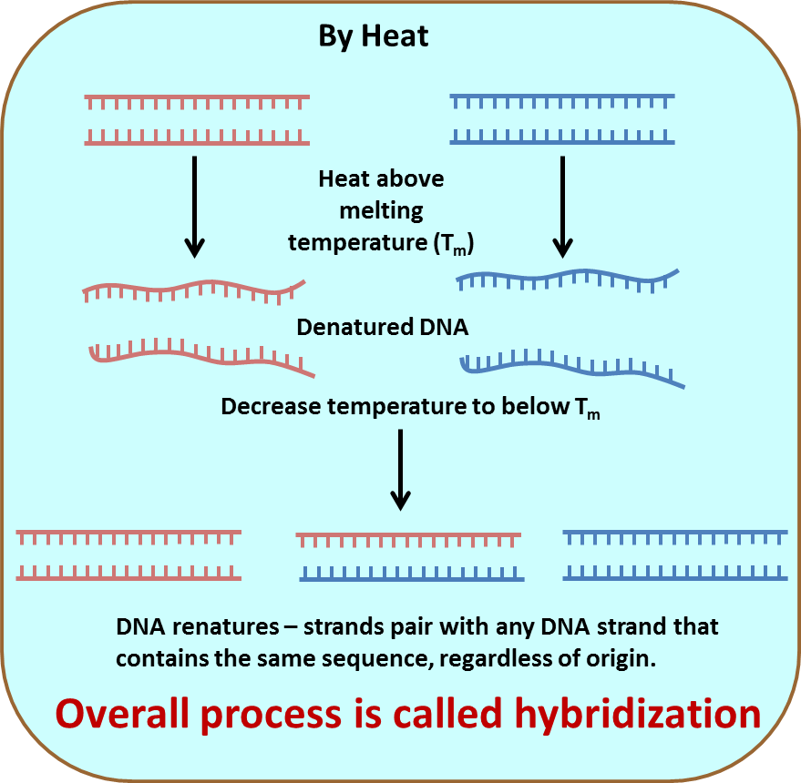
Another way to unwind the helix is by increasing the temperature. As the temperature is increased, hydrogen bonds between bases begin to break in regions of high AT content and near the ends of DNA molecules. As the temperature is further increased more bonds break until all hydrogen bonds between bases are broken and the DNA exists as two single strands. The temperature at which the two strands of a double helix are 50% dissociated into individual single strands (ssDNA) is called the melting point (T_{m}). T_{m} varies with the length of the DNA duplex and with the relative frequency of AT and GC base pairs. Both effects reflect the greater number of hydrogen bonds in DNA duplexes of greater length and high GC content.

The reverse process, in which denatured ssDNA is slowly cooled, allows complimentary sequences to spontaneously associate to form double helices. This process is called renaturation. Renaturation of denatured DNA occurs because a H-bonded double helix is energetically favorable compared to free single strands. When strands renature to form a double helix, they can associate with the same strand, with strands of the same sequence from a different source, or with strands that have only partial identity. When the strands are from a different source, the resulting dsDNA is called a hybrid and the process producing the molecule is called hybridization. You will hear these terms again in lectures covering methods used to detect specific genes in chromosomes and to detect changes in transcriptional programs.

V. DNA Metabolism.
V.A. Making Phosphodiester bonds during DNA Replication. During DNA replication, nucleotides are added to pre-existing chains of DNA (or in some cases to RNA). The reaction is carried out by enzymes called DNA polymerases. The order in which nucleotides are added to the growing chain is dictated by the sequence of nucleotides in the complementary strand, using the rules for complementary base pairing. Nucleotides are always added onto the 3’-end of the DNA chain, or to state this another way, synthesis always proceeds from the 5’ end of an elongating molecules and toward the 3’ end. The strand that is being read by DNA polymerase during replication always has the opposite polarity to the strand being synthesized. In other words, during replication the strand that serves as template for the newly synthesized strand is always read in the 3’ to 5’ direction.

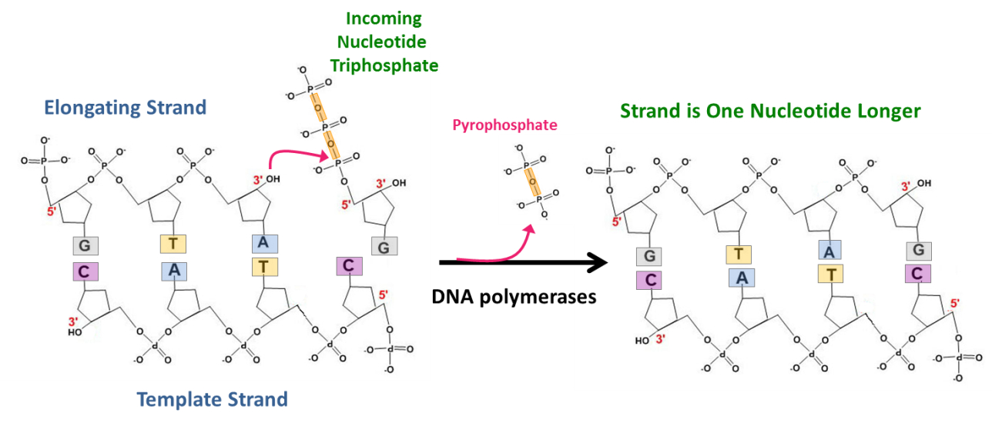
During DNA synthesis deoxynucleotide triphosphates, sometimes called dNTPs, are the precursors added onto the DNA strand. dNTPs have 3 phosphate groups attached sequentially to the 5’ carbon of the nucleotide. During DNA synthesis, a new bond is formed between the first phosphate in the dNTP and the oxygen on the 3’ end of the elongating strand. The resulting stand is now one nucleotide longer. Energy for this reaction is provided by the energy released by cleavage of the two “high energy” phosphate bonds in the dNTP; one of these is cleaved during the reaction to produce pyrophosphate and the second one is cleaved spontaneously soon after pyrophosphate release.

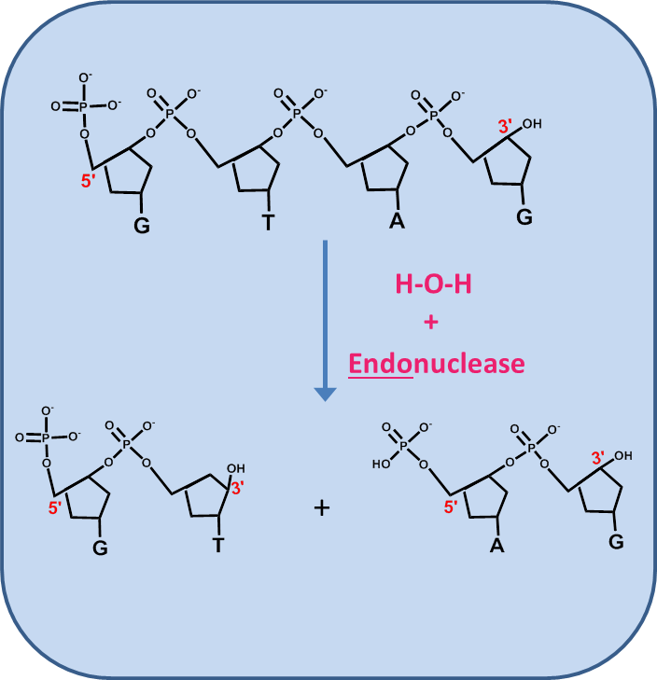
V.B. Breaking Phosphodiester Bonds. Just as living organisms make DNA, they also degrade DNA to remove nucleotides that have been damaged by chemicals or sunlight, to remove a nucleotide that has been incorporated incorrectly during DNA synthesis, or to degrade the DNA of invading microorganisms. Degradation is carried out by enzymes called nucleases which act by adding water across the phosphodiester bond, a process termed hydrolysis.

There are two general types of nucleases. Endonucleases hydrolyze phosphodiester bonds at internal sites in the DNA, producing two shorter DNA chains. Restriction endonucleases, which you learned about during high school or college, are examples of sequence specific endonucleases, i.e. they recognize a specific DNA sequence and cleave the DNA strand within or near that sequence.

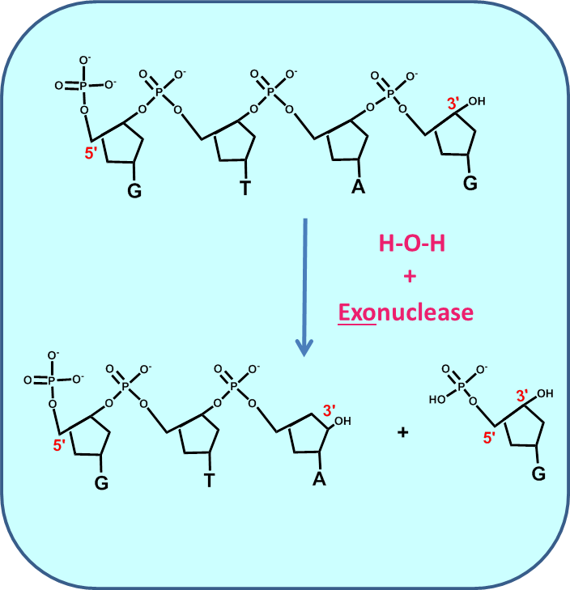
Exonucleases hydrolyze the phosphodiester bond linking the final nucleotide in a strand to its neighbor, and thus produce a single nucleotide monophosphate and a DNA strand that is one nucleotide shorter than the original. Exonucleases recognize the polarity of a DNA strand and digest from the end of a DNA strand. 3’ to 5’ exonucleases bind to a free 3’ end and digest toward the 5’ end of the DNA strand. Conversely, 5’ to 3’ exonucleases digest from the 5’ end towards the 3’ end. As will be discussed in the genome replication lecture, some DNA polymerases contain intrinsic nuclease activities in addition to their polymerase activities. This allows the polymerases to correct incorrect nucleotide addition (proofreading) and in some cases to digest away sections of DNA or RNA ahead of the polymerases.

V.C. Pasting Together DNA Strands. Nucleases, some types of DNA damage, and DNA replication, can leave behind nicks or breaks in the DNA backbone. These breaks (especially double-strand breaks) must be repaired so that the genome remains intact. Ligases are the enzymes responsible for joining together DNA chains at the sites of single or double strand breaks. Ligases are also the enzymes that (along with restriction enzymes) have made genetic engineering possible; ligases do not care whether the DNA strands they join came from a bacterium or a human.

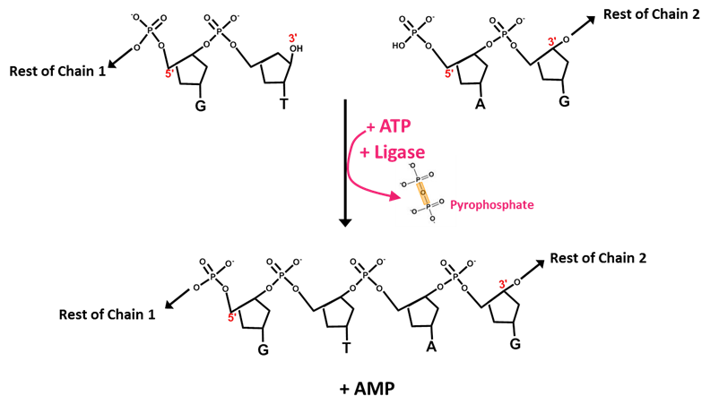
The reaction catalyzed by DNA ligases is more complex that simply sticking two ends together. In order for the bond to be made, the 5’ phosphate at the end of the second chain must be activated. This is done by cleavage of ATP to AMP and pyrophosphate which provides energy for the reaction.

